INDEPENDENT DIRECTED STUDIES - Proposal/Application Form

Student’s name: ______________________________ Grade _______

What is an Independent Directed Studies course and how does it fit with high school graduation?

Independent Directed Studies courses enable students to initiate their own learning and receive
credits towards graduation. These courses are intended to:
• expand course options for students
• allow students to pursue curriculum in greater depth and further develop their passion
• provide students with the opportunity to pursue further studies of interest.

An IDS course is an extension of one or more learning outcomes already identified in an existing Grade 10, 11 or 12 course (available for either Ministry Authorized or Board Authorized courses). The course must be rigorous, well thought-out and developed through a consultative process involving the student and the teacher. The standards for IDS courses are designed to maintain a high level of quality in the work undertaken. An IDS course is taken as an additional credit outside of the student’s regular timetable. Following the submission of applications, successful applicants will work with their IDS teacher to identify and develop the IDS course learning outcomes.

What are the potential benefits of participating in an IDS course?
• become a self-directed, independent learner
• develop collaboration and networking skills
• reach beyond conventional course boundaries
• develop skills that will prepare you for post secondary success
• develop critical thinking and problem-solving skills
• work with others with similar interests on a local or global basis
• opportunity to work with recognized community leaders
• add a unique dimension to your portfolio

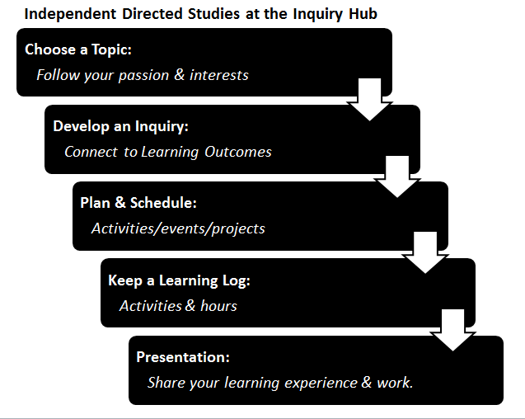
Proposal

Area of study: Credits: _____________ (2-4)

Topic/guiding question: Please outline the specific aspect of the area of study you are interested in pursuing. If possible, refer to specific learning outcomes listed for authorized courses on the BC Ministry of Education website: http://www.bced.gov.bc.ca/irp/welcome.php

Are you applying for this IDS course as:
an individual part of a cohort (Approved in advance)

If you are applying as part of a cohort, please list the names of others in the group:

Possible resources: outline some resources that may be helpful in supporting your learning
and the successful completion of your IDS. This may include print materials, on-line resources, community resources, etc. (Attach another page if needed.)

Mentors: A mentor is an adult, in addition to your IDS teacher, who has the expertise, skills, knowledge and resources to help and support you throughout your coursework. Please list a minimum of 1 potential mentor
Mentor’s name __________________________ Title/organization _______________________

Phone # ________________________________ email ________________________________

IDS teacher’s name: _______________________ Signature ______________________________

Another teacher that can serve as an area specialist to support you: _________________________

I understand that:
- Each credit equates to approximately 25-30 hours of learning time.
- I need to be proactive in maintaining regular contact with my IDS teacher and mentor.
- I am responsible for developing my plan and keeping my schedule of activities and projects.
- I am responsible for keeping a learning journal of activities & hours, and sharing my learning.
- If I work in a group, I still have independent responsibilities to maintain.

Student name: _______________________ Signature ______________________________

